**Lab 39**

**Classroom Activity: Creating VM on Azure**

**Task: Create Windows VM**

**Creating Your First Windows VM in Azure cloud**

Azure virtual machines (VMs) can be created through the Azure portal. This method provides a browser-based user interface to create VMs and their associated resources. This quick start shows you how to use the Azure portal to deploy a virtual machine (VM) in Azure that runs Windows Server 2019.

**Sign in to Azure**

Sign in to the Azure portal at [https://portal.azure.com](https://portal.azure.com/)

**Create virtual machine**

1. Type **virtual machines** in the search.
2. Under **Services**, select **Virtual machines**.
3. In the **Virtual machines** page, select **Add** then **Virtual machine**.
4. In the **Basics** tab, under **Project details**, make sure the correct subscription is selected and then choose to **Create new** resource group. Type *myResourceGroup* for the name.

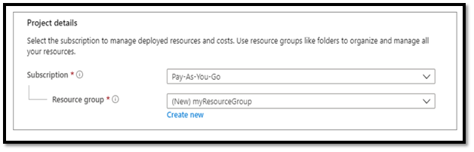

1. Under **Instance details**, type *myVM* for the **Virtual machine name** and choose *East US* for your **Region**. Choose *Windows Server 2019 Datacenter* for the **Image** and *Standard_DS1_v2* for the **Size**. Leave the other defaults.

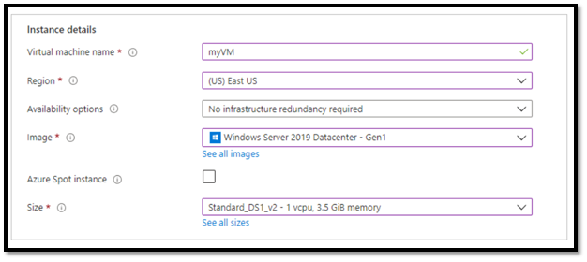

1. Under **Administrator account**, provide a username, such as *azureuser* and a password. The password must be at least 12 characters long and meet the defined complexity requirements.

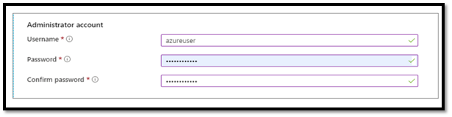

1. Under **Inbound port rules**, choose **Allow selected ports** and then select **RDP (3389)** and **HTTP (80)** from the drop-down.

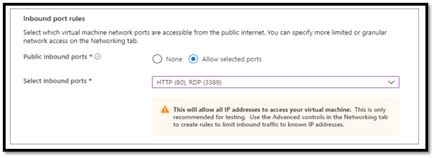

1. Leave the remaining defaults and then select the **Review + create** button at the bottom of the page.

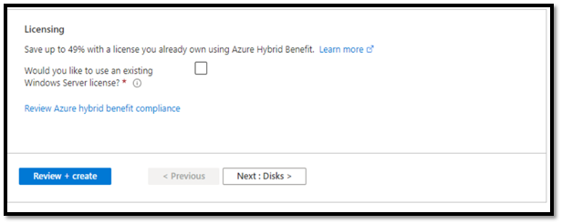

1. After validation runs, select the **Create** button at the bottom of the page.

1. After deployment is complete, select **Go to resource**.

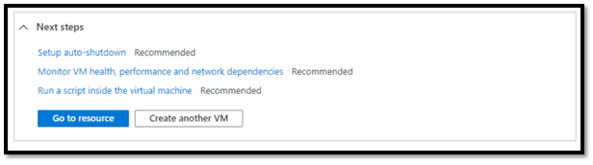

**Connect to virtual machine**

Create a remote desktop connection to the virtual machine. These directions tell you how to connect to your VM from a Windows computer. On a Mac, you need an RDP client such as this [Remote Desktop Client](https://apps.apple.com/app/microsoft-remote-desktop/id1295203466?mt=12) from the Mac App Store.

1. On the overview page for your virtual machine, select the **Connect** button then select **RDP**.

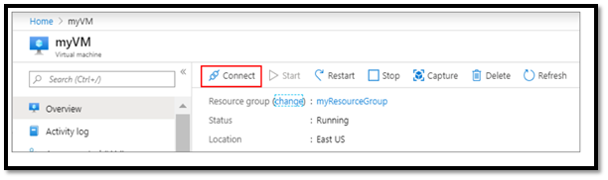

1. In the **Connect with RDP** page, keep the default options to connect by IP address, over port 3389, and click **Download RDP file**.
2. Open the downloaded RDP file and click **Connect** when prompted.
3. In the **Windows Security** window, select **More choices** and then **Use a different account**. Type the username as **localhost**\*username*, enter the password you created for the virtual machine, and then click **OK**.
4. You may receive a certificate warning during the sign-in process. Click **Yes** or **Continue** to create the connection.

**Clean up resources**

When no longer needed, you can delete the resource group, virtual machine, and all related resources.

Go to the resource group for the virtual machine, then select **Delete resource group**. Confirm the name of the resource group to finish deleting the resources.